# A century of Robotic Hands – Paper Review

# 3. A 1912–2018 DATABASE OF ROBOT HANDS

## 3.1. Compilation Criteria

We used the compiled information to analyze trends and isolate the technological enablers that are driving the development of the next generation of artificial hands, with particular attention to joint design, transmission architecture, and actuation systems. To include all the different design arrangements and solutions proposed to date, we **considered four types of joints: rigid, flexible, dislocatable, and soft continuous** (see Figure 4). We also considered the most common actuation principles in the literature (Figure 5) and different transmission architectures (Figure 6).

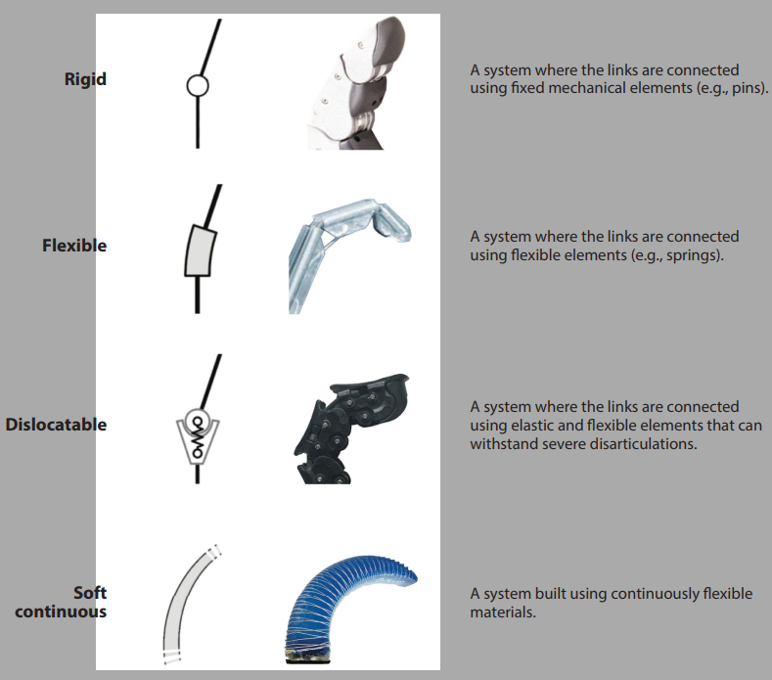

**Figure 4**

### Actuation Principles (Figure 5)

#### Rigid actuator

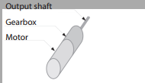

A device with negligible compliance that can reach and hold a specific position if external forces are exerted on its output. These actuators, which derive directly from industrial servomotors, are preferred when high accuracy is required.

#### Actuator with active impedance/admittance control

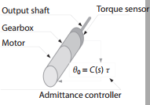

Similar to a rigid actuator but featuring an appreciable amount of compliance on its output, which comes from very fine tuning of control gains and/or the integration of an output torque (or force) sensor. This actuator can actively regulate the compliance (and damping) of the system and display more flexible interaction behavior, but its performance is constrained by the bandwidth of the control system, and its robustness is constrained by the torque limits of the output sensor (when present).

#### Series elastic actuator

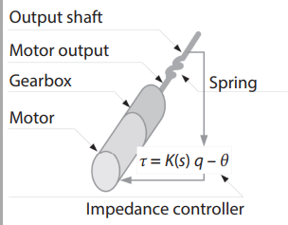

An actuator where the output shaft is driven through a spring. The system presents a fixed physical elasticity provided by the spring, which, being intrinsic, is not limited in bandwidth and is more robust than a torque sensor.

#### Explicit stiffness variation actuator

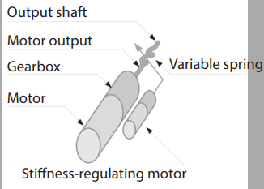

An evolution of the series elastic actuator that includes a physical elastic element on its output that can adjust its stiffness thanks to a second (usually smaller) actuation unit and a suitable mechanism. Because the implemented variable stiffness is physical, it has no bandwidth limitations, and the position and stiffness are regulated independently.

#### Agonist–antagonist variable-stiffness actuator

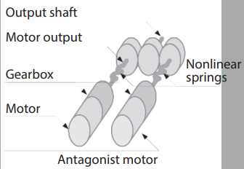

A system with an output behavior similar to that of the explicit stiffness variation actuator. It combines two similar (usually equal) prime movers, each connected to the output shaft through a nonlinear elastic transmission. It can control both the position and the physical stiffness of its output shaft by applying synchronous or opposite motions of the two prime movers. Stiffness and position are not controlled independently, and the stiffness behavior is usually nonlinear.

#### Variable-impedance actuator

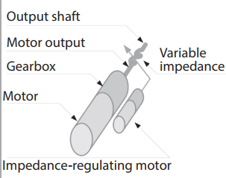

A further evolution of the actuators described above in which both the stiffness and the damping of the actuator output impedance can be changed, and both are implemented by the physical action of one or more elastic and damping elements. The equilibrium position depends on external forces and the mechanical properties of the actuator. Implementations, as well as advantages and disadvantages of the system, may vary significantly depending on the physical principles used to implement the variable stiffness and damping.

### Different types of transmission architectures (Figure 6)

#### Fully actuated

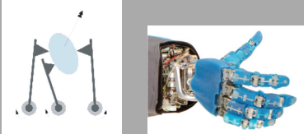

A system with direct control on each joint through a dedicated actuator for each joint.

#### Coupled

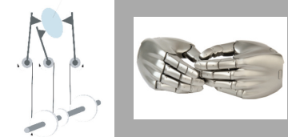

A system in which the number of joints is higher than the number of degrees of freedom, and the movement of one joint is always proportional to the joint(s) coupled to it.

#### Underactuated

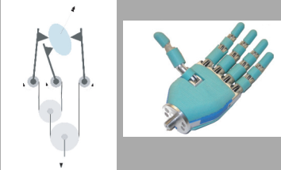

A system designed to allow passive movements between the degrees of freedom, which are often used to allow the adaptation of the hand shape to the grasped object.

# 4. Emerging Trends

growing number of open-source initiatives

* Open Hand Project (203): <https://www.eng.yale.edu/grablab/openhand/>
* Natural Machine Motion Initiative (231) <https://www.naturalmachinemotioninitiative.com/>
* Soft Hands platform (232) [**http://www.robotics.tu-berlin.de/menue/research/soft_hands**](http://www.robotics.tu-berlin.de/menue/research/soft_hands)
* opensource e-NABLE community (233) <https://enablingthefuture.org/>
* OpenBionics Initiative (234) <https://openbionics.org/affordableprosthetichands/>

Soft robotic hands exploit the flexibility of joints to adapt the shape of the figures to the object (or environment) when grasping, substantially simplifying the control strate

## 4.2. Architecture Simplification

The first and, for many years, most common approach to hand motion was full actuation, where the number of DoFs is equal to the number of joints; the DLR Hand II is a significant example of this architecture. A different approach to simplification is the coupled architecture. These hands use one actuator to control each DoF, and if one of the joints reaches a contact, all the joints coupled to it will stop. Fully actuated and coupled architectures have been predominant in the last decade, but underactuation has now emerged as a novel way to simplify designs. Underactuated systems allow passive movements between DoFs, which are determined by the equilibrium of the contact forces with passive elements such as springs or, less often, clutches or brakes (see 237, 238). Because they use fewer motors, they save space, weight, and cost, which has led to the development of a large number of underactuated hands and adaptive grippers (for a complete review, see 239).